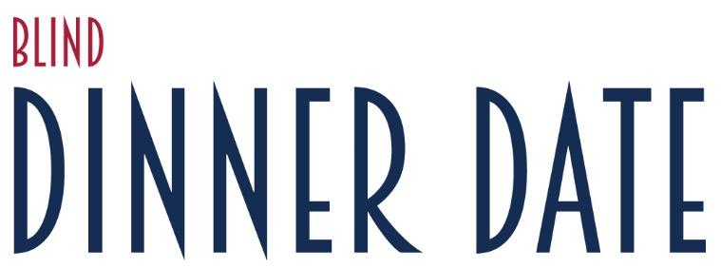
The Grand Rapids Lions Club is excited to present the 17th Annual Blind Dinner Date!
Dear [Salutation],
Please join us on Thursday, August 11, 2022 from 6:00pm to 9:00pm at Blandford Nature Center (1715 Hillburn Ave NW, Grand Rapids, 49504) for a casual outdoor evening in a beautiful strolling venue filled with great appetizers, drinks, and music.
At the event, we will also publicly recognize the achievements of several area professionals who are dedicated to improving the lives of individuals with vision loss.
Did you know that 80% of the information we take in each day is processed through our eyes? Too often, and without thought, the ability to see is taken for granted.
All funds raised through the Blind Dinner Date provide:
- Eye care to all ages through the Grand Rapids Lions Club Vision Clinic at Cherry Health, including children with special needs.
- Rehabilitation services for individuals in West Michigan with visual impairment or blindness through the Association for the Blind & Visually Impaired (ABVI).
Please help with our mission – review the sponsorship opportunities and participation levels on the attached form. For more information, please contact Ben Eavey, 2022 Blind Dinner Date Chair, at 616-719-9799 or ben@eavey.com.

To be included in the program, the form must be received by Monday, July 18, 2022.
Thank you for sharing our vision! We look forward to seeing you there!
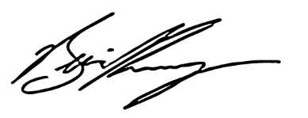

Ben Eavey
President, Grand Rapids Lions Club A Grand Rapids Lions Club Project

2022 SPONSORSHIP LEVELS – Thank you for your support!
Forms must be received by Monday, July 18, 2022.

Title Sponsor | $10,000
• Sponsor’s name will be included in the event title.
• Sponsor’s name and logo will be included in all event publicity and promotional campaigns,
including but not limited to mailings, web, and social media.
• Sponsor’s name and logo will be included on all event signage, programs, and print materials.
• The Title Sponsor will receive recognition from the podium during the event.
• The Title Sponsor will also receive 16 tickets to the event at no additional cost.
• The Title Sponsor will also receive post-event recognition through PR materials.
• An Appreciation Award for your personal display will be presented at the event.

Platinum Sponsor | $5,000
• Sponsor’s name and logo will be included in all event publicity and promotional campaigns,
including but not limited to mailings, web, and social media.
• Sponsor’s name and logo will be included on all event signage, programs, and print materials.
• The Platinum Sponsor will receive recognition from the podium during the event.
• The Platinum Sponsor will also receive 8 tickets to the event at no additional cost.
• An Appreciation Award for your personal display will be presented at the event.

Gold Sponsor | $3,000
• Sponsor’s name and logo will be mentioned in all event publicity and promotional campaigns,
including but not limited to mailings, web, and social media.
• Sponsor’s name and logo will be included on all event signage, programs, and print materials.
• The Gold Sponsor will also receive recognition from the podium during the event.
• The Gold Sponsor will receive 4 tickets to the event at no additional cost.

Silver Sponsor | $1,000
• Sponsor’s name and logo will be included in the event program.
• The Silver Sponsor will receive 4 tickets to the event at no additional cost.

Bronze Sponsor | $500
• Sponsor’s name and logo will be included in the event program
• The Bronze Sponsor will receive 2 tickets to the event at no additional cost.
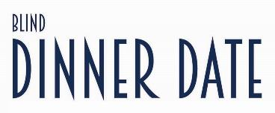
Sponsors & attendees: Please mark/circle your contribution:

Sponsorships: And/or Donations:
- Title Sponsor | $10,000 $250
- Platinum Sponsor | $5,000 $100
- Gold Sponsor | $3,000 Other $__________
- Silver Sponsor | $1,000
- Bronze Sponsor | $500

And/or Individual Tickets to the event on August 11, 2022, 6:00pm to 9:00pm:

_____ Individual tickets at $75 each, total of $___________________

Sponsor/Donor/Ticketholder Information:

Company _________________________________________________________________________
Contact ___________________________________________________________________________
Address___________________________________________________________________________
City _________________________________________ State ___________ Zip_____________
Phone _______________________ Email ________________________________________________

Please mark one: __ Check Enclosed __ Please Invoice __ Credit Card
Credit Card # ________________________________ Exp. Date ______________ CCV# ____________ Zip Code on Billing Address_______________ Signature____________________________________

Make checks payable to: Grand Rapids Lions Club

Please return this form to: Jennifer Helsel, ABVI
456 Cherry Street SE
Grand Rapids, MI 49503

Attendee Names:

1. _____________________________________ 2. _____________________________________

3. _____________________________________ 4. _____________________________________

(Space for additional attendee names on the following page)

Please note: Vegetarian and gluten free food options will be readily available.
For questions or additional information, contact Ben Eavey at 616-719-9799 or ben@eavey.com

Additional Guests:

5. _____________________________________ 6. _____________________________________

7. _____________________________________ 8. _____________________________________

9. _____________________________________ 10. ____________________________________

11. ____________________________________ 12. ____________________________________

13. ____________________________________ 14. ____________________________________

15. ____________________________________ 16. ____________________________________

