ZOOM Meeting Instructions

Here are a few simple and easy steps to get on to a Zoom Meeting

1. You will receive an invitation in your email for the meeting.
It will show the day, time, the zoom link for the meeting and who is hosting the
meeting

2. At the time of the meeting, click on the link (blue https link in the email.)
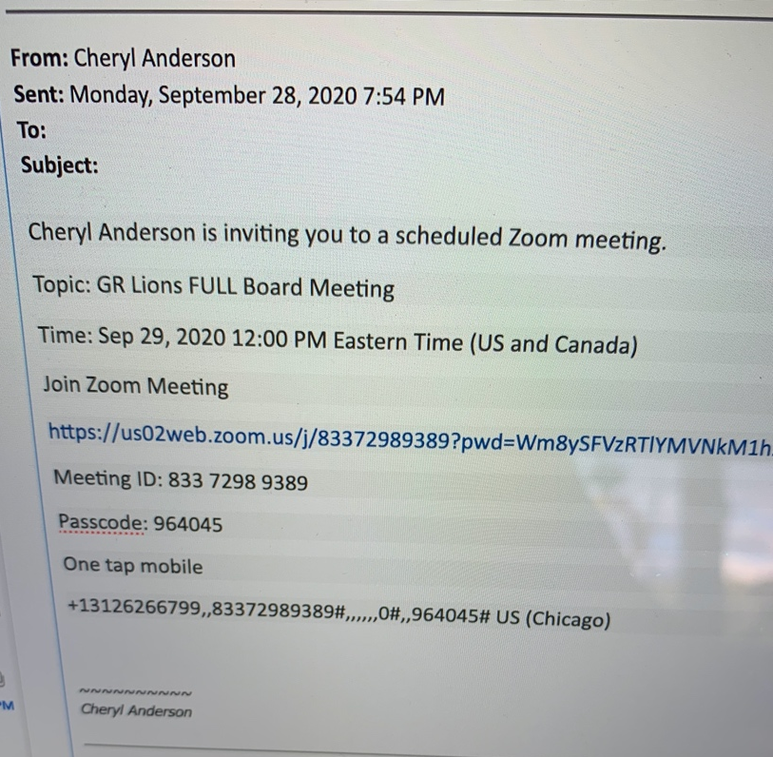

Your computer should take you to the www.zoom.us page and may ask you to
open an account, it is FREE!!! There is no charge to get on the site.
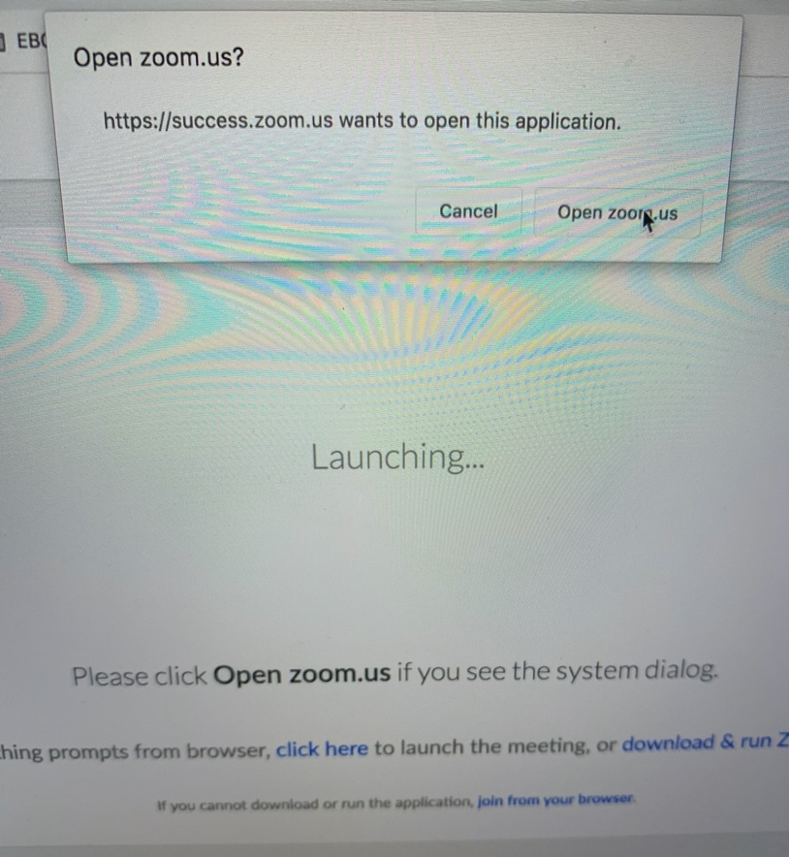

3. If there is a passcode required to get into the meeting, (which I will always send
out meetings that require passcodes) the passcode can be found in the email.
For example, the passcode for this meeting was 964045. Type it in when
prompted

4. You are now in the waiting room of the meeting. JUST WAIT!!!!!

5. You will have a button to “mute” and/or “start “video” so we hear and see you.
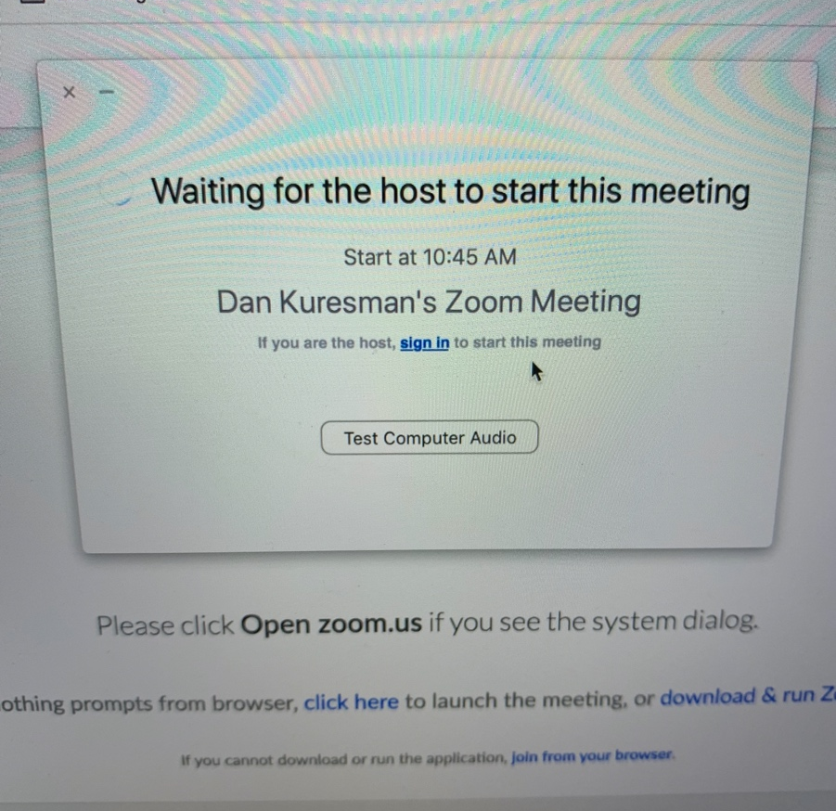

*******On the bottom of the Zoom screen is a “CHAT” button. BE CAREFUL,
the chat can go to “EVERYONE” or you can use the drop down menu and only send it to one person.

