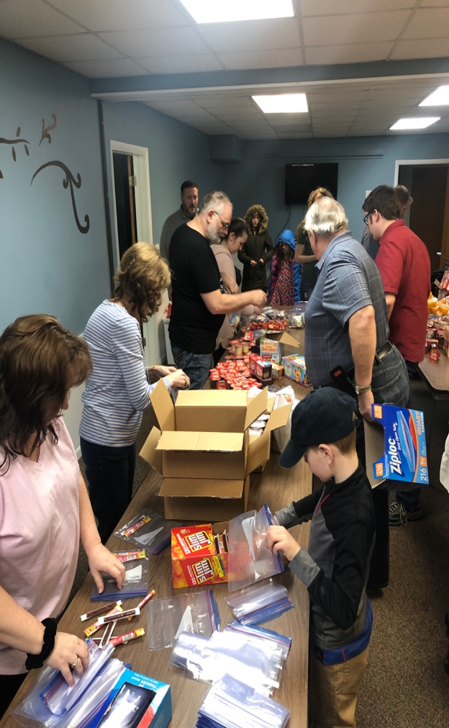
Family Service Project - Kids Meals
Saturday, March 2, 2019
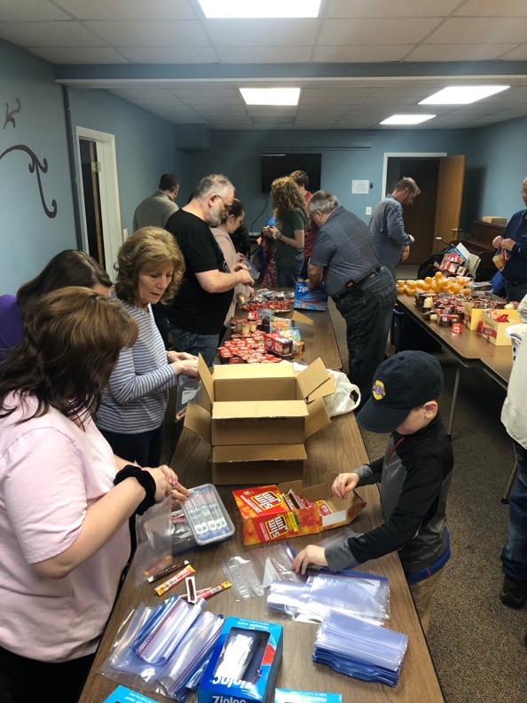

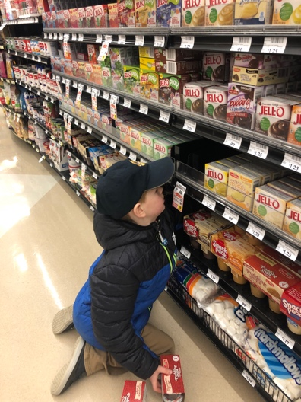
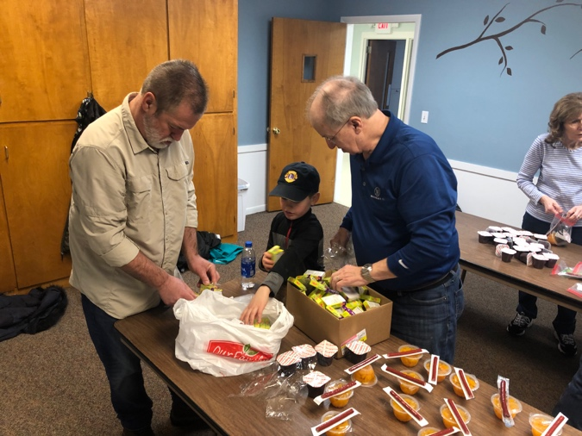
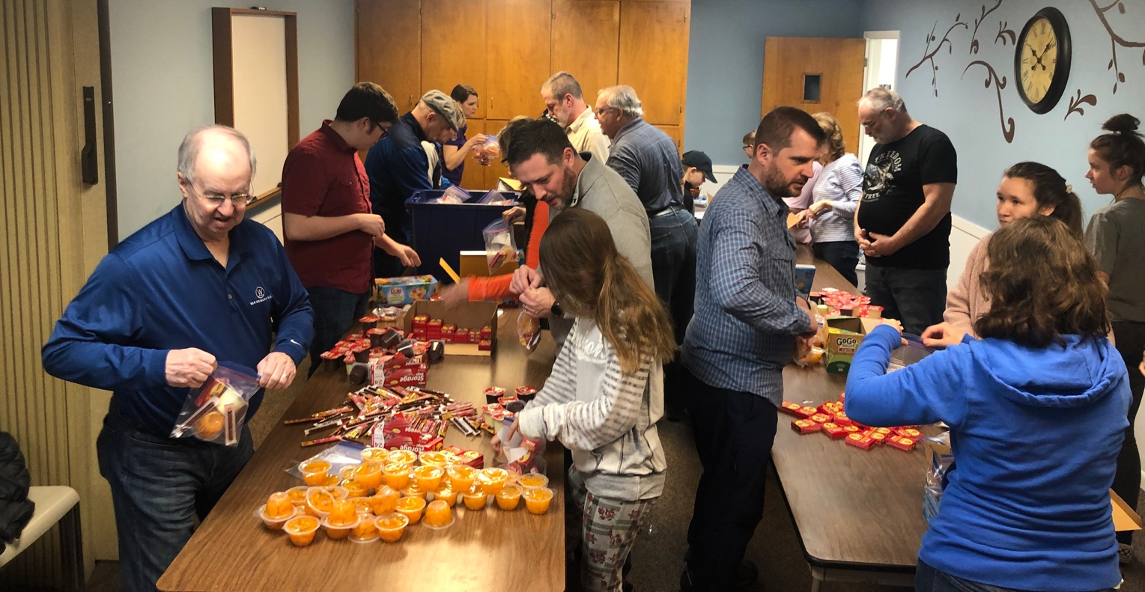

Goal = 200

Packed
608 Meals!!!

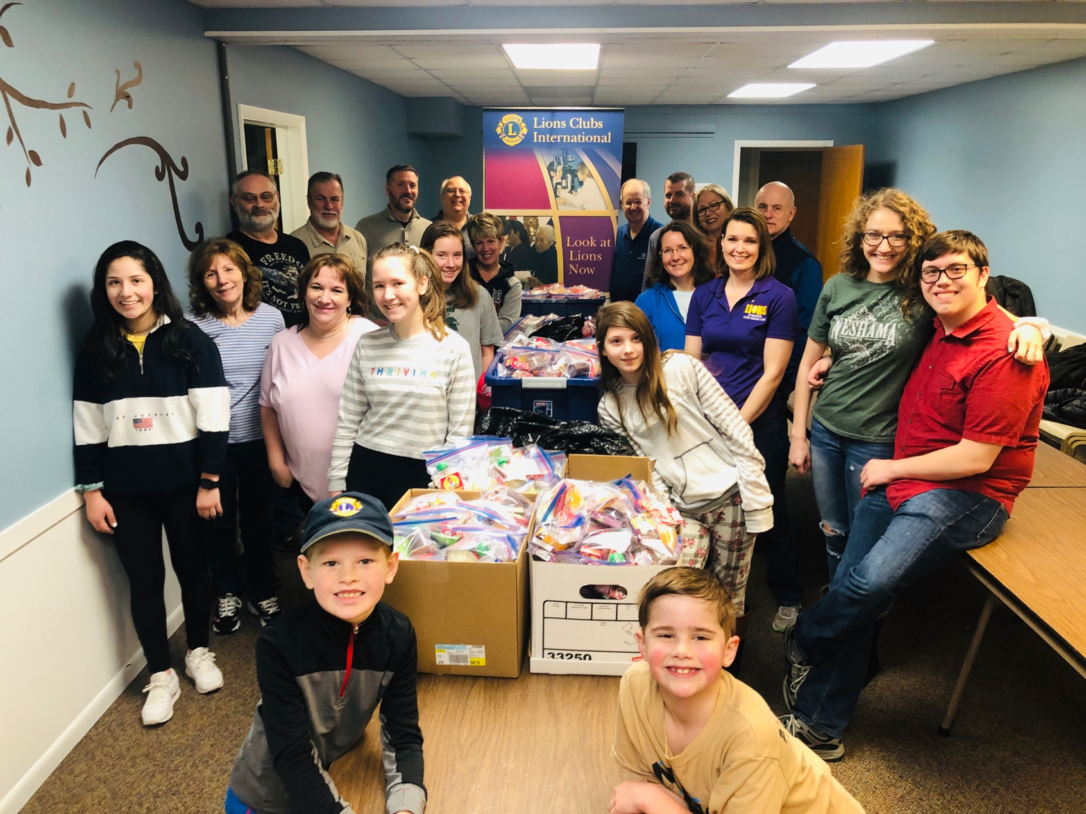

Thank you to:
Gary Anderson & Grandson, Carter Bolhuis
Dave & Shauna Bayer
Shawn and MaryBeth Eyestone & Children:
Rachel, Kayla, Jenna and Jenna’s friend, Kayla
Ben & Sherah Eavey & Children:
Reagan, Taylor, Jackson & Sarah Vredenburg
Jamie & Gail Junod
Dave & Jackie Lefers
Bob & Alice Snyders
Rick Walker

23 Workers
608 Meals Packed!!!!

