Come out and support Lion Thomas Dandridge.
12 pastel paintings hanging at Trinity Methodist Church until April 1, 2019
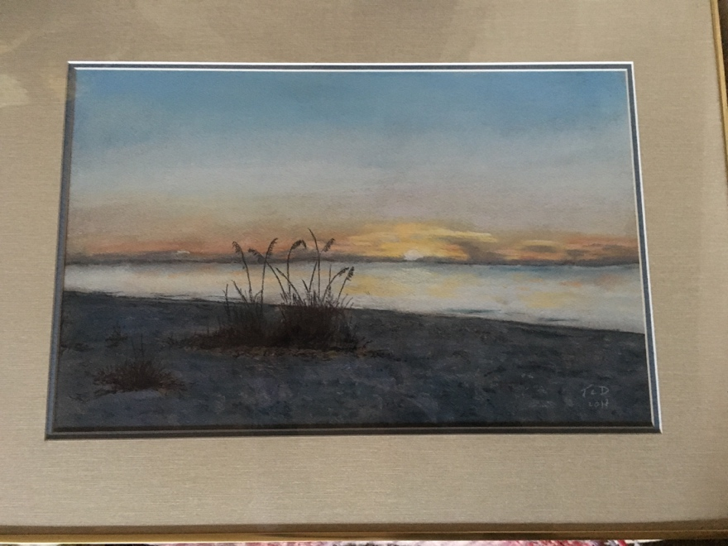

Trinity Methodist Church which is near the corner of Fuller and Lake in Grand Rapids. The church is accessed from the parking lot on the south side, behind the building, by ringing a bell for access.

The gallery, in the lounge of the church. is open Monday through Thursday from about 9:00 to 4:30, and of course Sunday, and may be closed at lunchtime.

