Recap-Nov 13, 2018 Luncheon Mtg,
Social Capital and Philanthropy
Meeting Tuesday, Nov 13, 2018 at The University Club.
Meeting started at 12:52 pm with the pledge.

Announcements;
- Pres Ed Thauer attended the Leadership Institute at Higgins Lake with approx. 100 Lions from around the state. It was very educational and encouraging.
- 34th Lions of MI Foundation raffle tickets are now available. $10/ticket. There are 10 prizes given out from $5,000-$100. See Pres Ed Thauer for tickets
- The 8,000 eyeglasses were sent out yesterday for our February mission trip to Mexico. The mission is planned for four days, seeing between 500-600 patients a day. Tonight at recycling, we start over with preparing glasses for future missions. Last week, there were 27 people working at recycling. We need you to volunteer. The recycling center is looking for a few more mentors for the recycling center to help teach our many new volunteers the steps in the processes. If interested, contact Scott Brady, scottbrady2120@gmail.com
- Kim Gary had surgery to repair his torn achilles tendon yesterday.
- Monday, Nov 19th at 7:30 am there will be the first Dinner in the Dark committee meeting at the Big Boy Restaurant downtown. If interested contact Ben Eavey, ben@eavey.com.
- Holiday Shopping will be Saturday, Dec 8 at the Cascade Meijer. There will be 12 visually impaired shoppers and 28 children from Sabbath Ministries.

The Program:
Dr. Salvatore Alaimo, Associate Professor at GVSU spoke on Social Capital and Philanthropy. Social capital is about the value of social networks, bonding similar people and bridging between diverse people with norms of reciprocity (Dekker and Uslaner 2001) The meaning of Philantropy is not only giving money, but also volunteerism, advocacy and social activism.
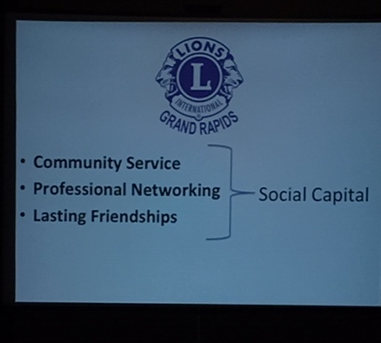
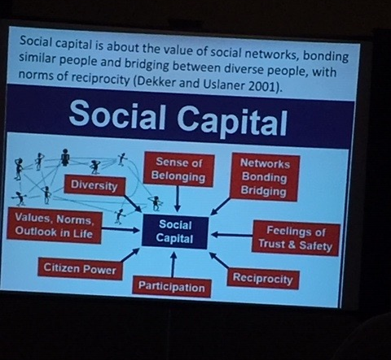

Similarities to Lions
- Volunteering is an action for the good of the public. Donating is not only money but can include blood, organs, time, skills or an expertise talent. All of these can be more important than money.
- Advocacy, which also includes volunteering, but is the voice for those who don’t have a voice. An example would be pleading their case. A great youtube video is Fred Rogers going before the Senate Subcommittee asking for public television funding for his show. If you haven’t seen this video, check it out, “May 1, 1969: Fred Rogers testifies before the Senate Subcommittee on Communications”.
- Social activism is taking the time to take a great risk to change policies. These policies could be public, government, non-profit or the informal sector. An example would be the right for women to vote.

There is a book, “Bowling Alone: The Collapse and Revival of American Community” by Robert D Putnam. The book speaks about memberships in volunteer organizations declining. Mobile phones and social media are a huge part of this decline. Social media was supposed to connect us but it is actually separating us. So what should we do? 1. Taking ownership in community service. 2. Professional networking doesn’t mean you know how to network but you need to have a meaningful conversation. Lasting friendships is a product of proper social networking. Organizations like the Lions and other service organizations are important. There is an underlying trust and reciprocity that comes with service organizations.

Dr. Alaimo gave an example of one of his students who came from Palestine. She was visually impaired and as much as GVSU talks about diversity, the university was lacking in helping those students that are visually impaired. She worked hard to help GVSU and other students with disabilities bring in the help/equipment needed. She graduated at the top of her class and now is an advocate for disabilities back in Palestine.

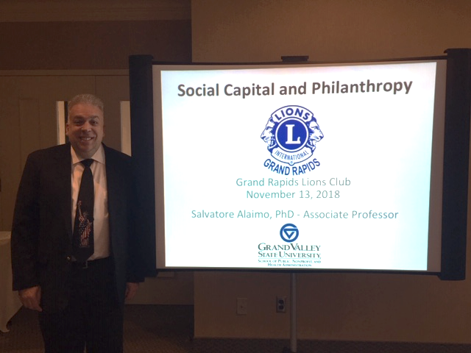

alaimos@gvsu.edu

Meeting adjourned at 1:31

Next Tuesday, Nov 20, 2018 12:00pm

Steve Kelso, Kent Country Health Dept

University Club (10th floor of the 5/3 bldg,)

111 Lyon St NW

Grand Rapids MI 49503

Respectfully submitted,

Lion Cheryl Anderson

